Probability and Statistics Assignment
  - Report 2: Appendix
Martín Carrera Valdez

Link 1: Kaggle “World Economic Dataset” used in the assignment
https://www.kaggle.com/datasets/ahmadfirman/world-economic-2025/data

Table 1: Variables included in study
Variable | Type | Level of measurement | Unit
Name | Qualitative | Nominal | Text label
Wealth | Qualitative | Nominal | Text label
Region | Qualitative | Nominal | Text label
GDP | Quantitative | Ratio | Billions of USD
GDP per capita | Quantitative | Ratio | USD
GDP growth | Quantitative | Ratio | Percent (%)
Inflation rate | Quantitative | Ratio | Percent (%)
Unemployment rate | Quantitative | Ratio | Percent (%)
Debt to GDP ratio | Quantitative | Ratio | Percent (%)

Table 2: Measures of location, dispersion, and symmetry
Measure | Descriptive statistic | GDP (billion USD) | GDP per capita (USD) | GDP growth (%) | Inflation rate (%) | Unemployment rate (%) | Debt to GDP ratio (%)
Location | Mean | 1 063.00 | 26 464.2 | 1.116 | 6.204 | 6.9 | 64.28
 | Median | 257.00 | 14 870.0 | 0.700 | 3.100 | 5.2 | 58.20
Dispersion | Range | 29 183.00 | 138 144.1 | 42.300 | 172.900 | 33.1 | 233.70
 | IQR | 524.00 | 31 777.3 | 1.700 | 2.710 | 4.1 | 38.90
 | Standard Deviation | 3.82 | 33 426.5 | 3.821 | 21.367 | 6.1 | 39.00
 | Coefficient of Variation (%) | 0.36 | 126.3 | 342.383 | 344.407 | 88.4 | 60.67
Symmetry | Skewness coefficient | 8.67 | 3.5 | -1.532 | 5.44 | 1.8 | 2.05

Table 3: Frequency distribution of GDP per capita
GDP per capita  (USD) | Frequency | Relative Frequency | Cumulative Frequency | Cumulative Relative Frequency
[0 – 18 000) | 114 | 0.67 | 0.67 | 0.67
[18 000 – 36 000) | 27 | 0.16 | 0.82 | 0.82
[36 000 – 54 000) | 11 | 0.06 | 0.89 | 0.89
[54 000 – 72 000) | 10 | 0.06 | 0.95 | 0.95
[72 000 – 90 000) | 5 | 0.03 | 0.98 | 0.98
[90 000 – 108 000) | 3 | 0.02 | 0.99 | 0.99
[108 000 – 126 000) | 0 | 0.00 | 0.99 | 0.99
[126 000 – 144 000) | 1 | 0.006 | 1.00 | 1.00
Total | 171 | 1.00 | - | -

Table 4: Tests of Mean and Variance of the Wider Data
 | GDP (billion USD) | GDP per capita (USD) | GDP growth (%) | Inflation rate (%) | Unemployment rate (%) | Debt to GDP ratio (%)
Sample mean | 1 063.00 | 26 464.2 | 1.12 | 6.20 | 6.9 | 64.28
Sample standard deviation | 3.82 | 33 426.5 | 3.82 | 21.37 | 6.1 | 39.00
Population mean | 637.51 | 21519.1 | 1.12 | 39.36 | 7.4 | 60.95
Population standard deviation | 2703.93 | 33426.5 | 3.82 | 14.51 | 6.1 | 39.00
Confidence interval 95% | (234.59; 1040.43) | (16538.1; 26500.1) | (0.55; 1.68) | (37.20; 41.52) | (6.5; 8.3) | (55.13; 66.76)

Table 5: Inflation Rate comparisons between Rich and Poor countries
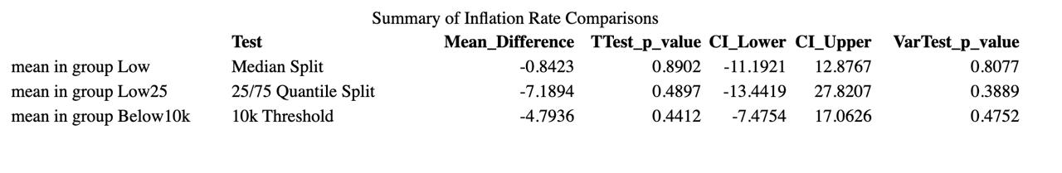
Table 6: ANOVA test for unemployment rate in different regions

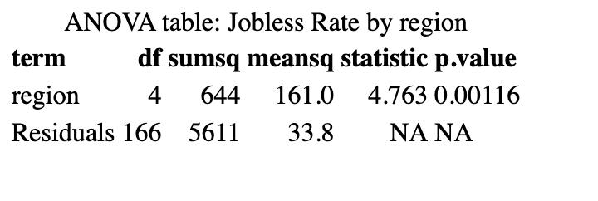
Table 7: Post-hoc pairwise comparison of unemployment rate between regions

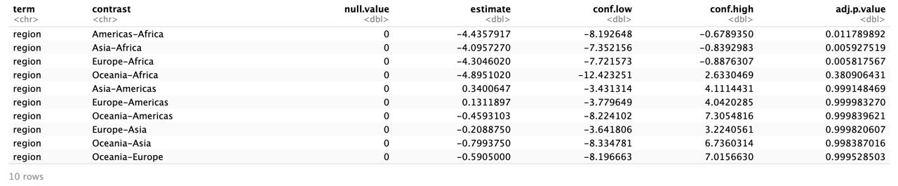
Figure 1: GDP Histogram
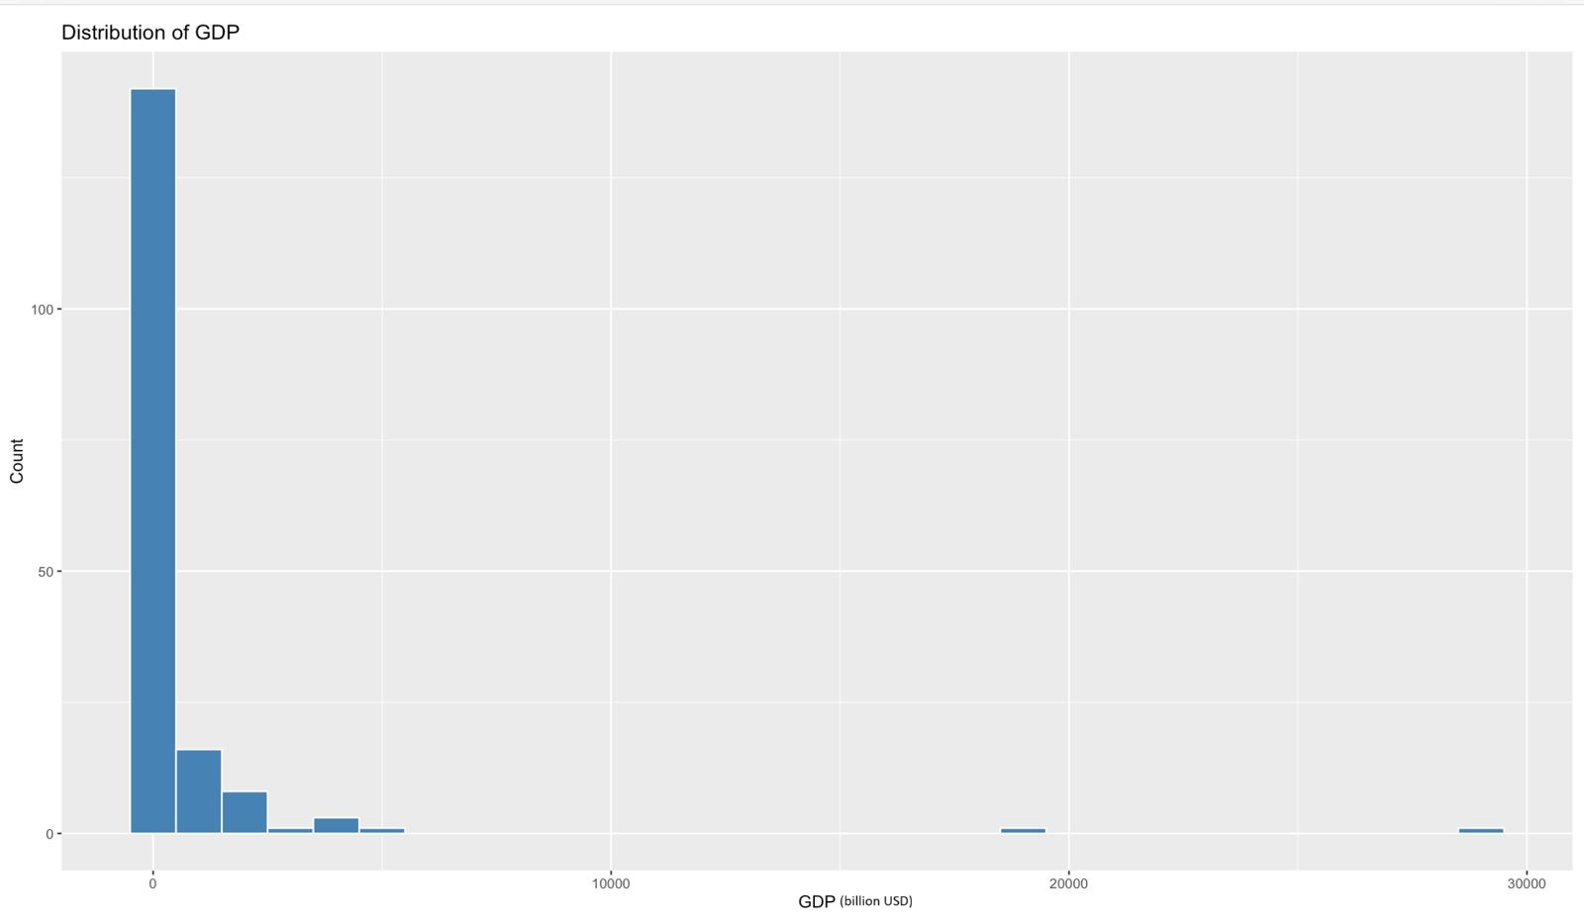
Figure 2: Unemployment rate Frequency Polygon
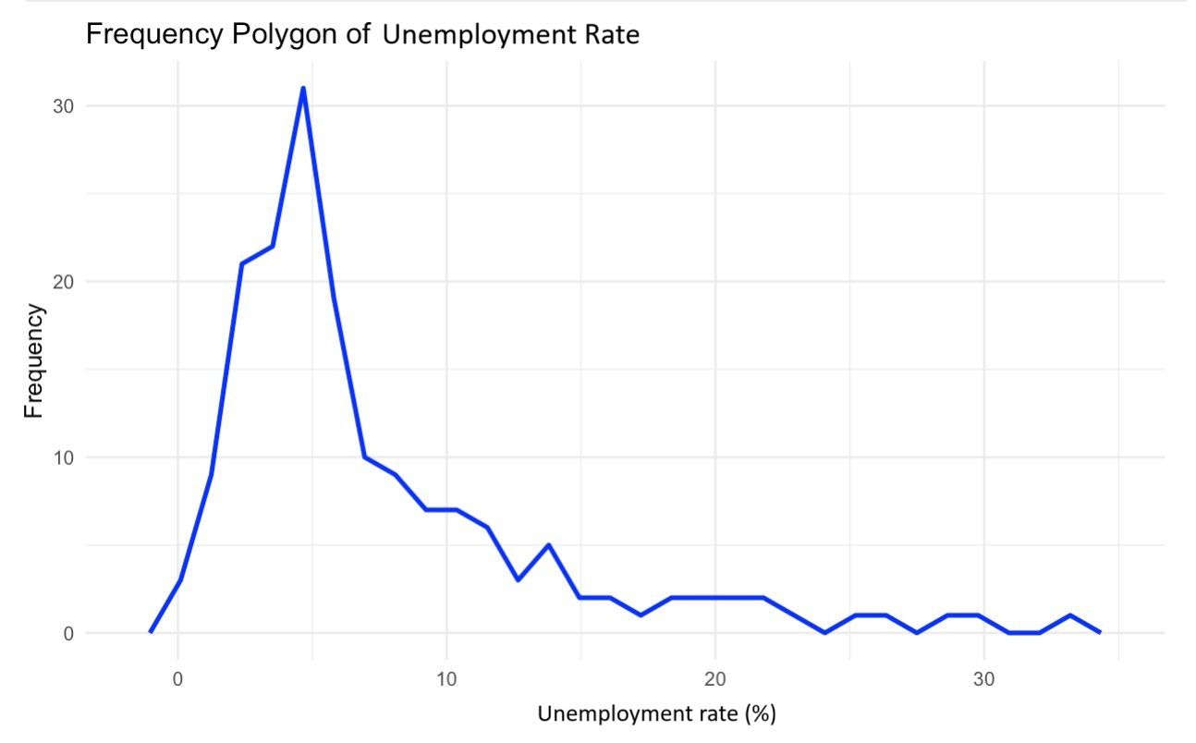

Figure 3: GDP Growth Cumulative Frequency Polygon
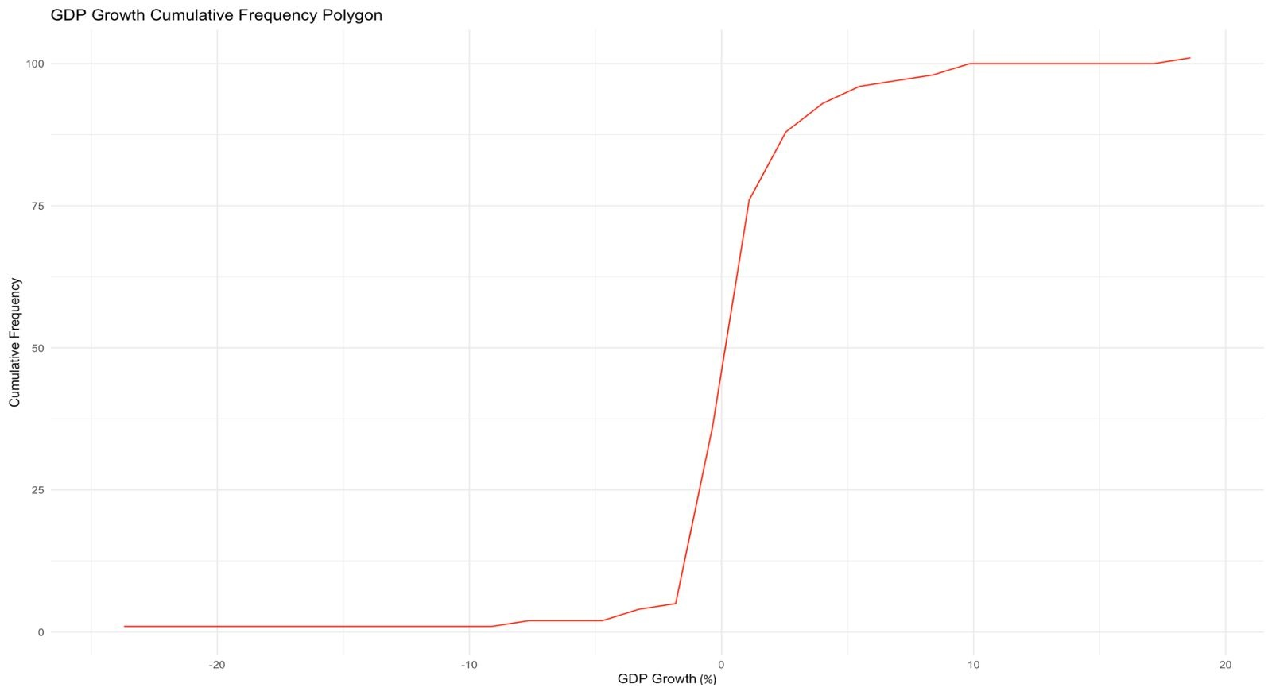

Figure 4: Boxplot of inflation rate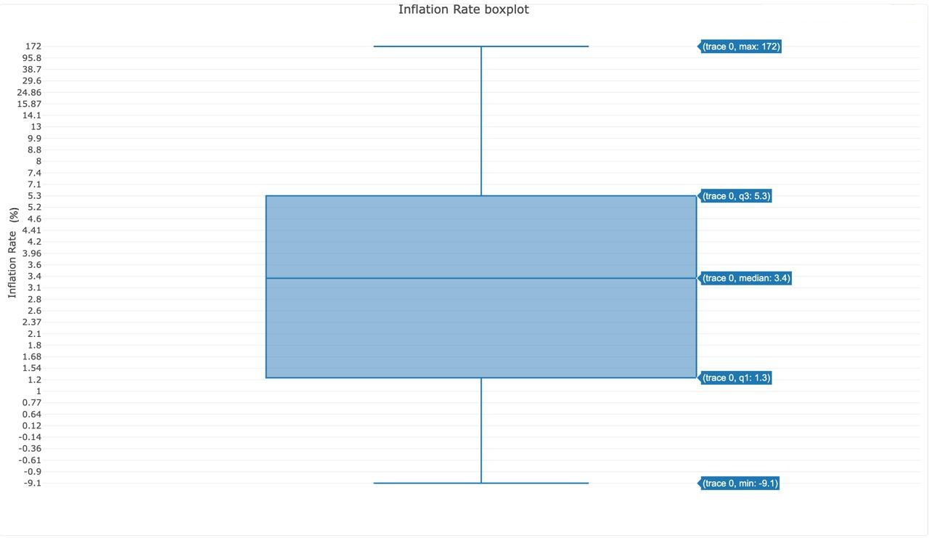

Figure 5: Boxplot of debt-to-GDP ratio
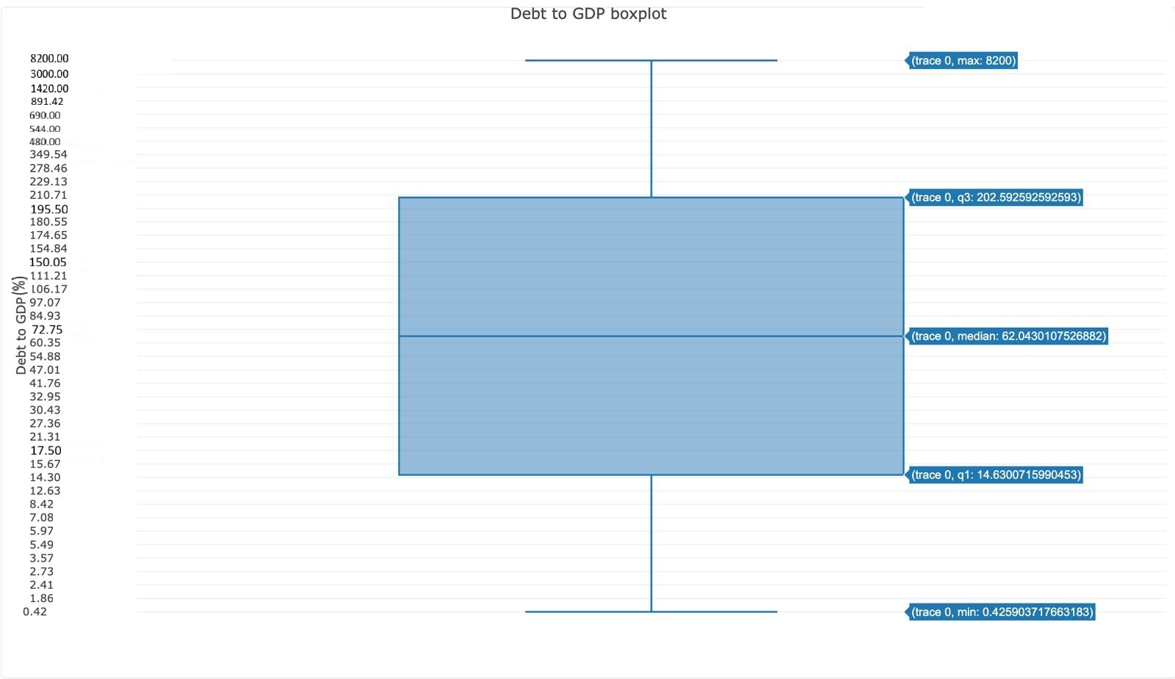
Figure 6: Scatterplot of GDP Growth against Unemployment Rate
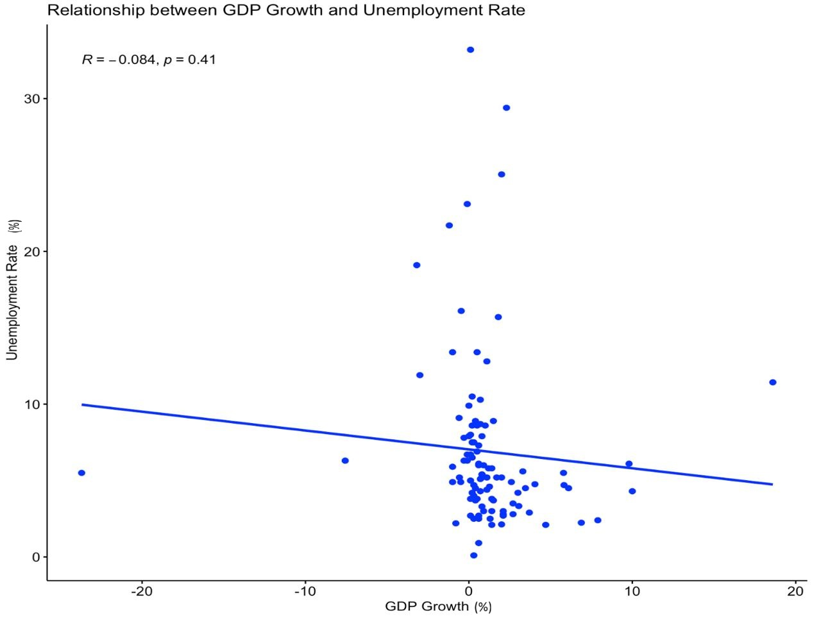
Figure 7: Scatterplot of GDP Growth against Unemployment Rate with regression line and confidence interval band
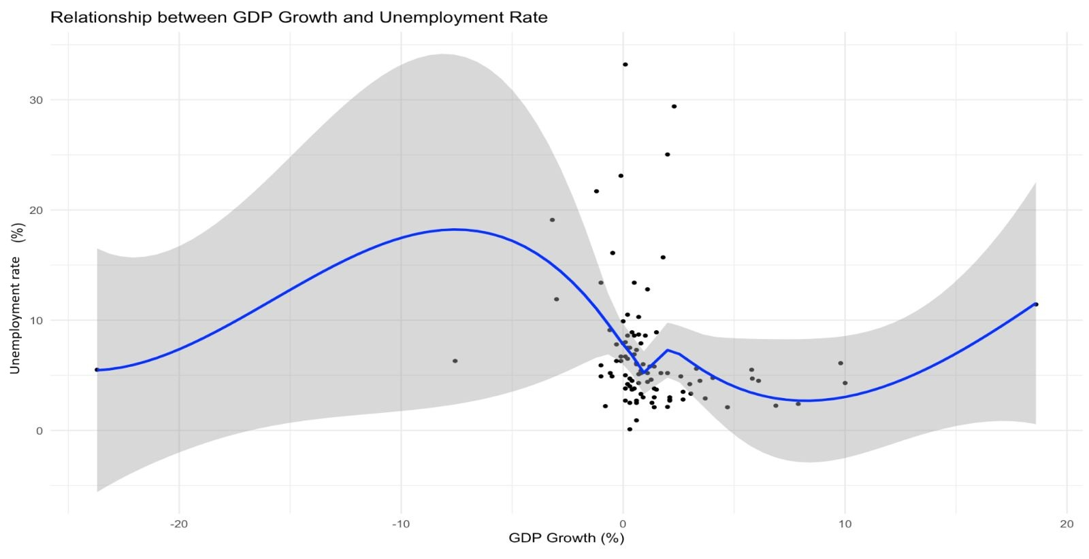
Figure 8: Scatterplot of Unemployment Rate against Inflation Rate with regression line: “Phillip’s Curve”
